

CET341 – Assignment 2 Report

A brief comparison of SQL and NoSQL databases using PostgreSQL and MongoDB with an e-commerce database

Name: Syed Hani Haider Naqvi
Student No: 240539894

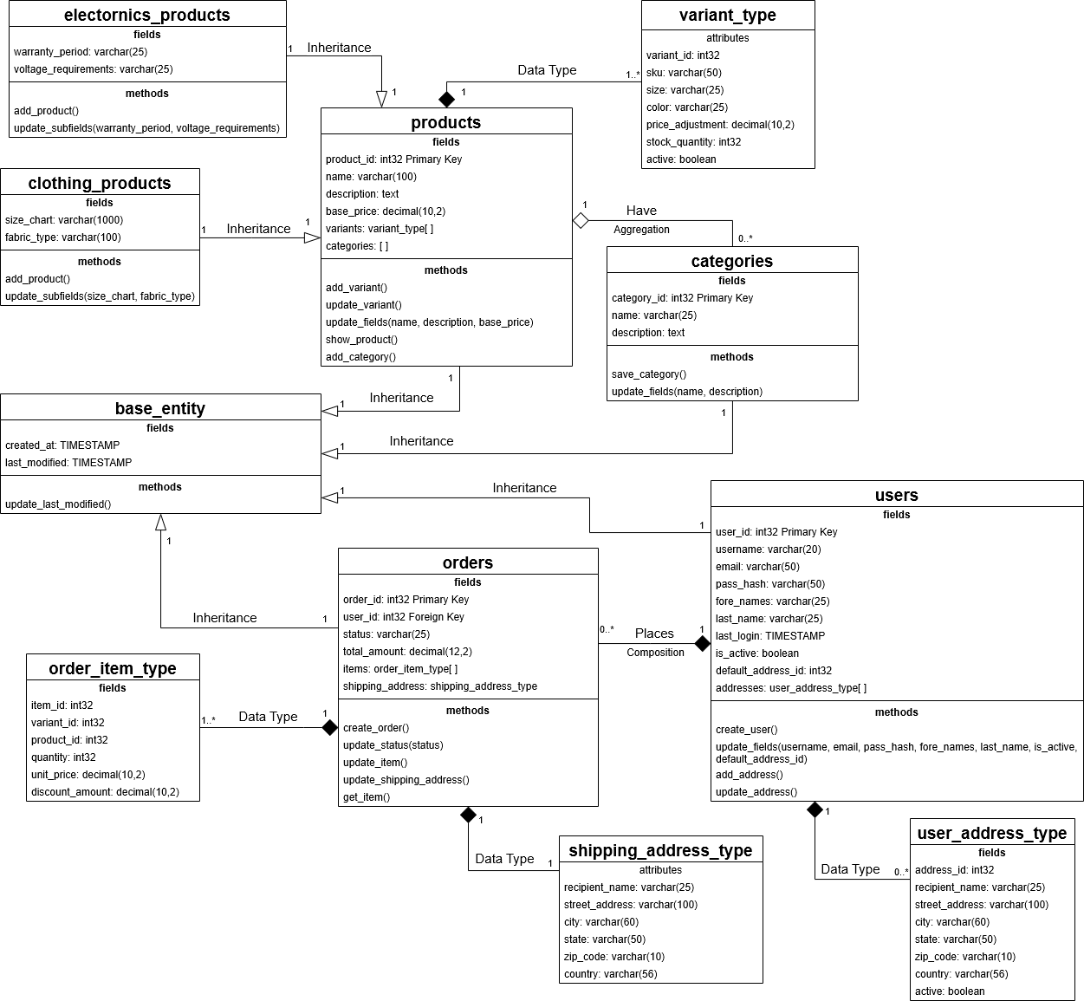
Task One:
The above UML diagram represents a part of an e-commerce platform. I worked on a project during my HND to build an e-commerce store app. This database is inspired by that project, but I’ve decided to build a skeleton model with only the core entities needed to complete the tasks of this project, as a full database for a project like Shopify would be very huge and too complicated. There are mainly 4 entities in the PostgreSQL and MongoDB databases. The Products, categories, orders, and users. All of them inherit temporal fields from the base entity. The base entity in the original design was for creating event logs, but it only serves as a single place to inherit temporal data from in this design. There are 4 composite data types/nested documents in this design. A user_address for storing an array of addresses that the user saves, a shipping_address to ensure past orders data doesn’t change in the records in case the user changes an address. There is an order_item type for storing order items with IDs that refer to products and variants, and other data related to the order item. There is a variant type for products to store an array of variants. Lastly, the products are divided into subtypes to ensure specific product-related fields are added only to the correct product, and there aren’t too many null fields in the records. The methods listed in the entities would be built for production implementation, but only the ones needed for this demonstration are built in the submitted database.

Task Two:
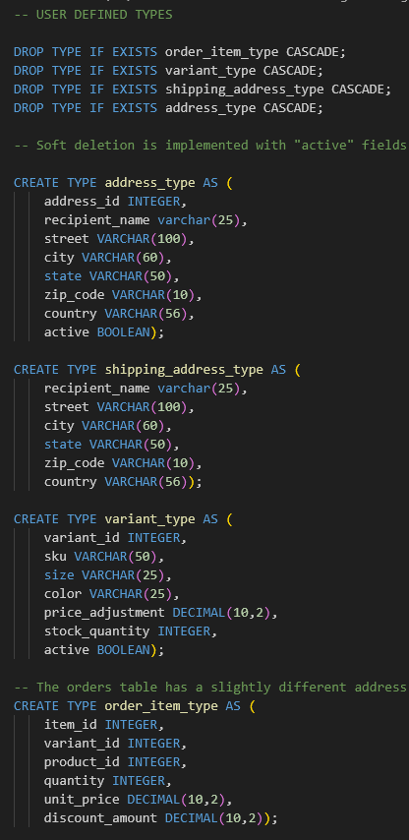
The many-to-many relationship in PostgreSQL is done with a junction table as the other option would have been to add all the categories to the products and all the products to the categories table (Strausz, 2023). There is a direct 1-1 link between products and categories for the primary category of the product. All the SQL commands are in uppercase to allow better readability of the script.
Creating types:
The types are dropped (with all the tables and triggers by the CASCADE clause to prevent dependency errors) and created successfully.

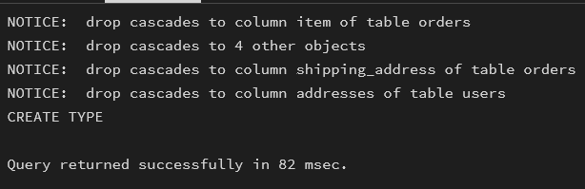
Running the entire type block returns this:

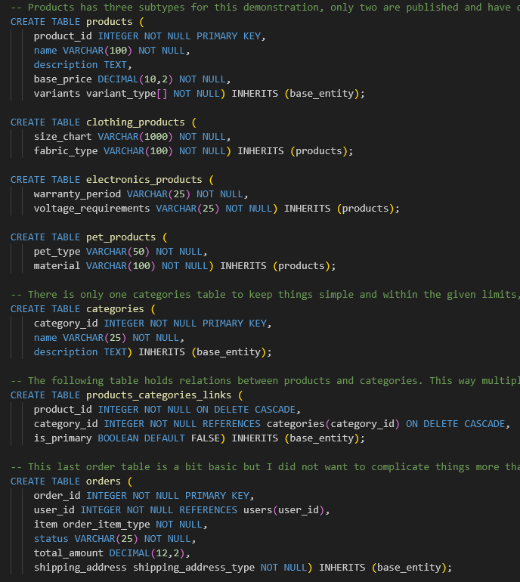
Creating Tables:
All the tables are dropped by the types as dependencies, but the drop statements are there, and the tables are created successfully. The pets_products table is there to showcase an unpublished product and has no stock or categories linked to it.

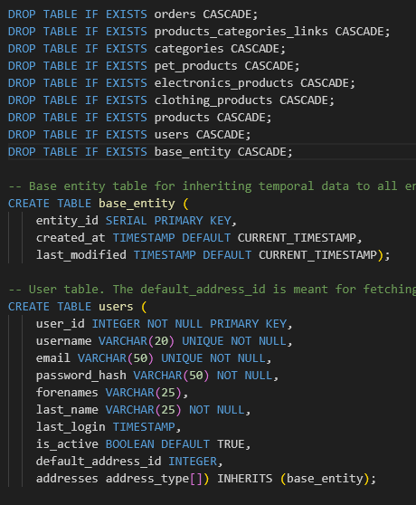
Running the entire table block returns this:
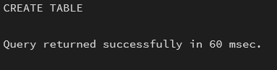

Creating Procedure:
There is one procedure used to update a field in an array for Query C. It is dropped, then created successfully. The procedure takes 3 arguments. The first one is the product_id to find the product, the second is the variant_id to find the variant, and the third is the new price that will be updated with the procedure. It finds the variant in a WITH clause and uses FOR UPDATE to prevent any other transactions from using it for the duration of this transaction. There are proper constraints in place to raise exceptions on null values and negative prices.
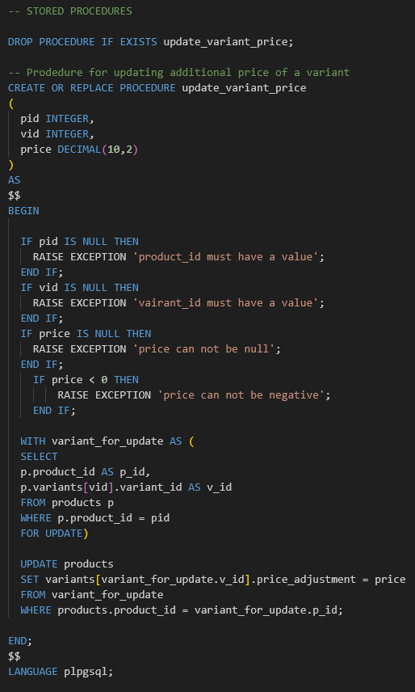

Running the stored procedure block returns this:
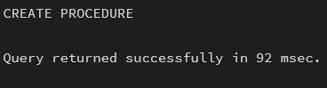

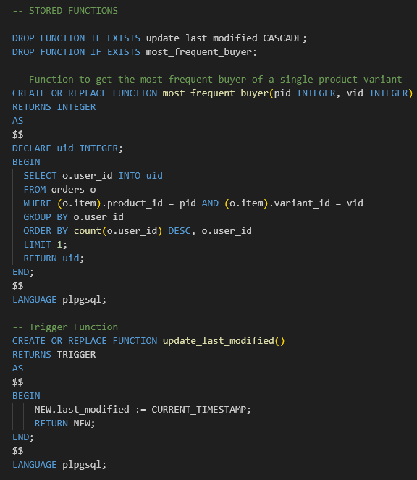

Creating Functions:
There are two functions, one used in Query A and one for the triggers. They are dropped and created successfully. The first function is to fetch the user who has ordered a variant of a product the most frequently. It takes the product_id and the variant_id as arguments. The second one is to update the last_modified timestamp on the products table, and the update is triggered.
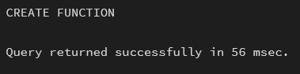
Running the functions block of the script returns this:

Creating Triggers:
There are three update triggers for the update procedure. They are dropped when the types are dropped, as they have dependencies, but they have drop statements as well and are created successfully every time.
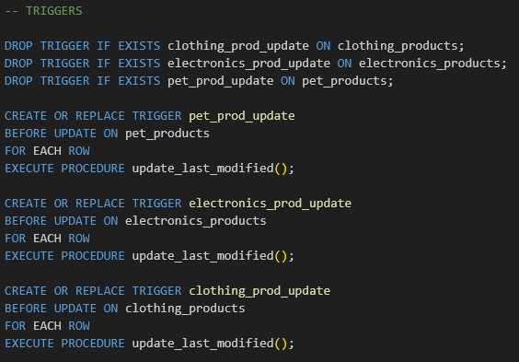

Running the procedure block returns this:
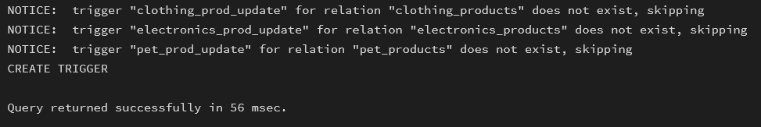

Inserting sample data:
There are 22 users, 15 products (5 clothing, 5 electronics, 5 pets), 15 categories, and 200 orders in the sample data set. All are inserted successfully. There is a single insert command for each table instead of an insert command for each individual value.
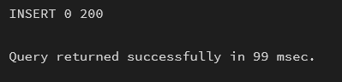

The entire script to create all the objects and insert the sample data takes about 100-110 milliseconds on average.
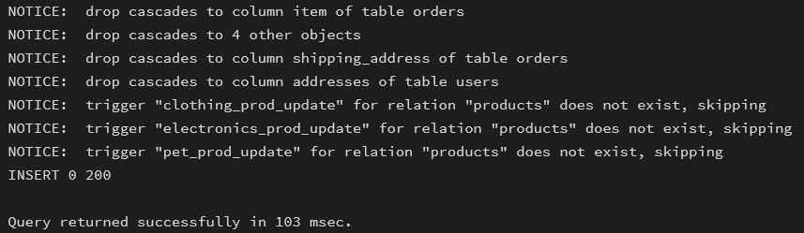

Task Three:
The MongoDB script starts with a db = connect() to create a database and then it mainly has db.collection.insertMany commands and a createIndex command below each collection. Indexes are created on user_id, product_id, category_id, and order_id fields in the users, products, categories, and orders collections, respectively. This is to emulate how indexes would be created when switching from a relational database to MongoDB with old data. Hypothetically, after deployment, all the documents would get the new auto-generated _id in the referenced id fields, but as I used the same data, I kept the IDs from the SQL database for simplicity. Of course, the collections are modified to reduce the number of collections (e.g. the junction table for products x categories is gone) and denormalise data where it makes sense. As the documents in JSON format take up thousands of lines, I will just attach unique examples from each document.

Creating/connecting DB:
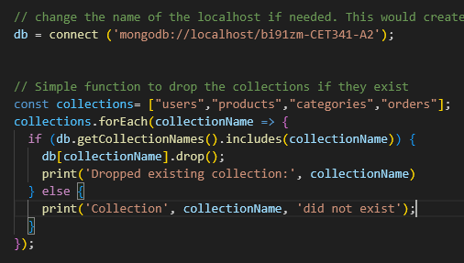
The script first attempts to connect to the DB or creates it if it doesn’t exist. Right after that, a for loop checks for the collections and drops them if they exist:
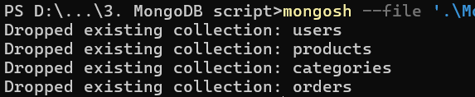
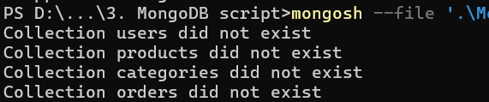

Users:
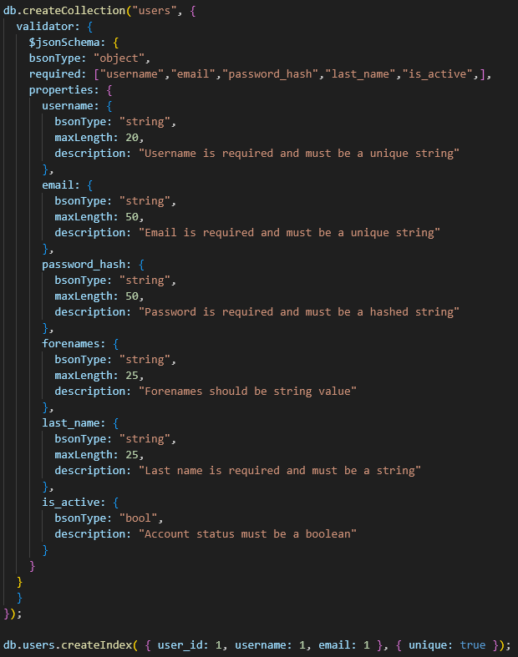
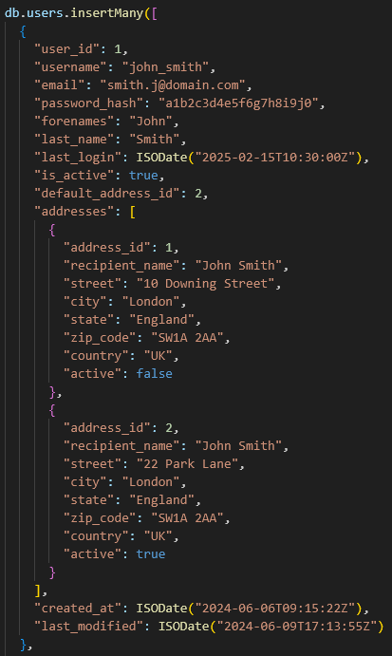
The user collection has pretty much the same format as the PostgreSQL table, as changes were not needed here. The collection is created and validation rules are added first, then indexes, and then the data is inserted. I will only show one example of the user document to showcase all the fields as the only difference is the number of addresses between users and fields are the same across all documents:

Products:
There is only one collection for products, unlike the three tables for each type. The product collection has 2 more attributes than the SQL tables did, and those are product_type (for specifying which type of product it is) and the primary category’s name. The specific product type/subtable-based fields are added to their respective document, so there are 3 different kinds of documents in this collection. I have attached a screenshot of the validations and index, and one document of each type. Each product has 6 variations. I have only kept 2, expanded to reduce the size, the fields are standard in all variations.
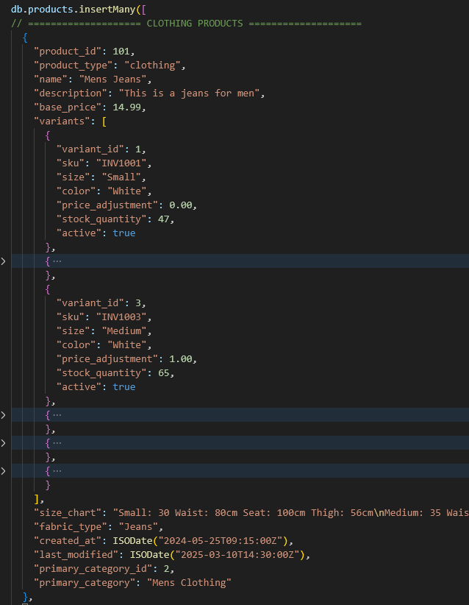
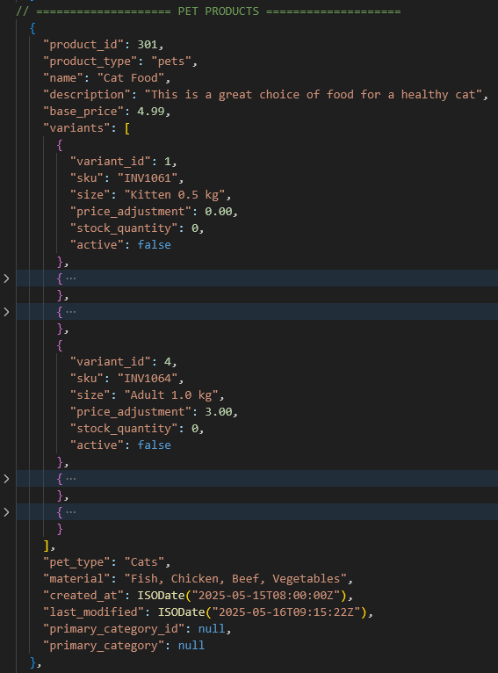
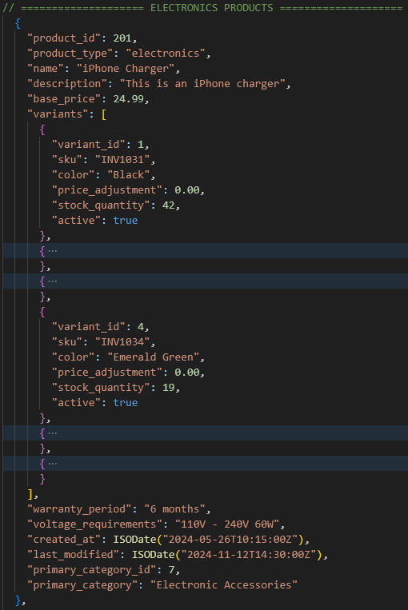
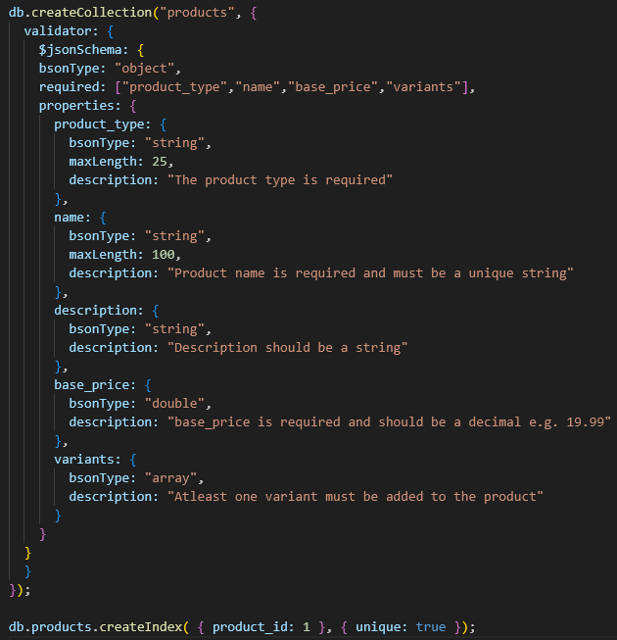
Categories:
The categories are essentially the same with the addition of one attribute, an array of the product IDs linked to the category has been passed as the last field in this collection. As the category documents are small, I was able to get two in one screenshot with the validations and the index as well.
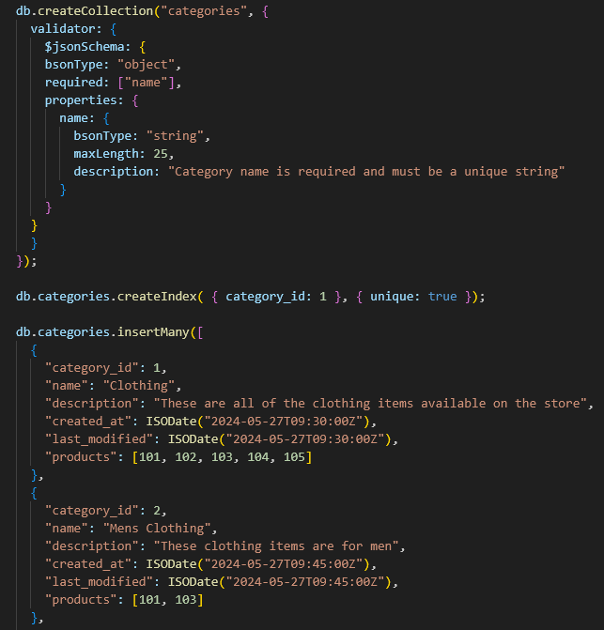

Orders:
Order collection is essentially the same, with a key addition of the user’s full name in the user. This addition is made to improve efficiency and avoid extra $lookup aggregations for a more optimised pipeline. I have included one document example, as all the documents follow the same pattern.
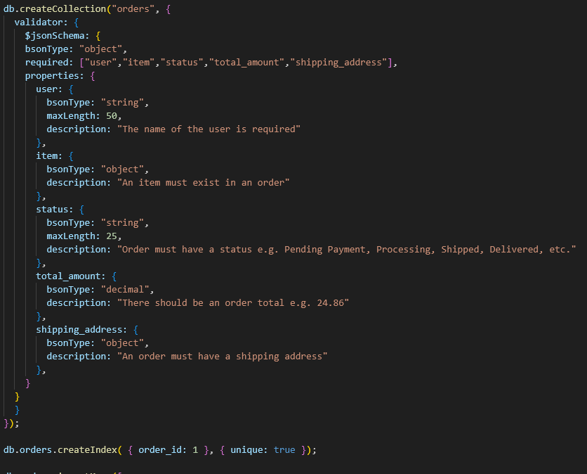

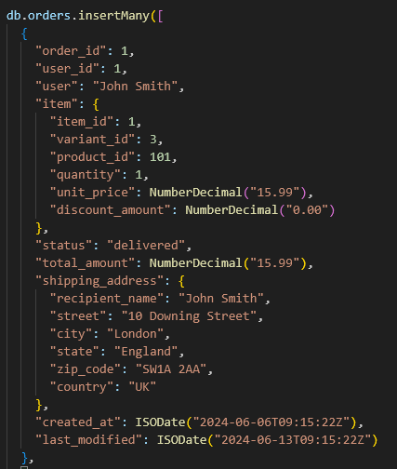

Task Four:
There are quite a few key differences in my implementation of NoSQL and SQL databases. The main differences are the reduced entities in the NoSQL DB as inheritance is done through nested documents, and the data is denormalised. The main reason for denormalising the data (e.g. adding the user’s name in orders, adding child-specific fields in just one product collection, etc) was to improve performance since it would reduce the number of $lookup stages in aggregation pipelines and joins in NoSQL can be very resource intensive (MongoDB Docs, no date). I also made sure all the fields used in $lookup were declared as indexes to improve the performance of the aggregation pipelines (Gupta, 2024).

I have removed the base entity as it was easier and faster to inherit it into other tables than adding it manually, and the base_entity table could be altered later to hold more data that could help generate system logs, however, having a separate collection for holding temporal data would have drastically affected the performance of MongoDB whenever a temporal restraint had to be used in an aggregation pipeline. I also removed the child entities of products, as MongoDB offers a flexible schema, and the child-specific field could just be added to the main products entity. To ensure that it was easier to know which child-specific fields were in which document, I enforced the product_type field through schema validators, and a new product_type can be sent from the backend to add another type of product instead of creating a new child table for it. Furthermore, I did not need to add a collection for the junction table, which holds many-many relationships in SQL, as I could just pass an array of products inside categories and the name of the primary category inside products. In SQL, foreign key fields can only hold one value, and foreign keys can not be inside arrays, but relations are not established through keys in NoSQL, so the product IDs could just be saved inside an array. Instead of having 9 collections for each table, I was able to get that down to 4 collections by denormalising some data and using NoSQL features.

I made as many validation rules and unique indexes as needed for this demonstration (it is not an exact schema match with the SQL DB), but of course, there would be a lot more rules built in the backend of the application as well in production. Building all the constraints and validation rules in the database can increase the database maintenance workload. Most database constraints are going to be in application logic anyway, but having duplicate validations for everything can increase the resources and cost of running things. It would be best to build constraints for the fields that must remain unique or used in relations or performing tasks where a certain value is expected in the database, and keep the rest of the validation rules on the application side to bring down the cost of running things. Engineers should strive to build better logic rather than needing safeguards.

Tasks Five and Six:
Query a: A join of three or more tables – you should consider various types of join in this query (e.g. inner join, left/right/full outer joins, etc.) and the query must include a restriction on the rows selected

This query shows the total sales for each variant, their category, and the user who purchased it most frequently (with the help of the stored function in SQL). It is very helpful to see the best-performing variants in your store. The restrictions are applied on the joined entities to avoid getting unnecessary data (one example is the limit clause in the stored function to only get the most frequent user and not every user that has purchased an item)

In this query, the variants array is unnested and cross-joined with products to create a row for each variant.
Then orders have a left join to show a count for and the accumulated total sales for each variant, without removing the ones that do not have any sales.
After that, the primary categories for the products are fetched with an inner join to restrict products that have a category, as unpublished products are not assigned to a category (two joins as the relational data is stored in a junction table).
Lastly, the most frequent users are added with a left join to not exclude any items that have not been purchased.

In the aggregation pipeline, users are not joined as the user’s full name is already in the orders collection, but the orders are looked up twice, once for the count and once for the user’s full name.
SQL code
SELECT
p.product_id AS id,
p.name AS name,
CONCAT(v.size, ' | ', v.color) AS variant_details,
count(o.*) AS orders,
sum(o.total_amount) AS revenue,
c.name AS main_category,
CONCAT(u.forenames, ' ' ,u.last_name) AS most_purchased_by

FROM products p

CROSS JOIN unnest(p.variants) AS v

LEFT JOIN orders o ON v.variant_id = (o.item).variant_id AND p.product_id = (o.item).product_id

JOIN products_categories_links pc ON p.product_id = pc.product_id AND pc.is_primary = TRUE
JOIN categories c ON pc.category_id = c.category_ID

LEFT JOIN users u ON most_frequent_buyer(p.product_id, v.variant_id) = u.user_id

GROUP BY p.product_id, v.variant_id, v.size, v.color, c.name, u.forenames, u.last_name

ORDER BY count(o.*) DESC, p.product_id, v.variant_id;
MongoDB code
db.products.aggregate([{
$match: { primary_category_id: { $exists: true, $ne: null }}
},
{ $unwind: {
path: "$variants",
preserveNullAndEmptyArrays: true
}},
{ $lookup: {
from: "orders",
localField: "product_id",
foreignField: "item.product_id",
let: {vid: "$variants.variant_id"},
pipeline: [{
$match: { $expr: { $eq: ["$item.variant_id", "$$vid"]}}},
{ $group: {
_id: null,
count: { $sum: 1 },
revenue: { $sum: "$total_amount" }}}],
as: "orders"
}},
{ $unwind: {
path: "$orders",
preserveNullAndEmptyArrays: true }
},
{ $sort: {
"orders.count": -1,
product_id: 1,
"variants.variant_id": 1 }
},
{ $lookup: {
from: "orders",
localField: "product_id",
foreignField: "item.product_id",
let: { vid: "$variants.variant_id" },
pipeline: [{
$match: { $expr: { $eq: ["$item.variant_id", "$$vid"]}}},
{ $group: {
_id: {
user_id: "$user_id",
user: "$user"
},
count: { $sum: 1 }}
},
{ $sort: {
count: -1,
"_id.user_id": 1 }
},
{ $limit: 1
},
{ $project: {
_id: 0,
name: "$_id.user"}
}],
as: "most_freq_user"
}},
{ $unwind: {
path: "$most_freq_user",
preserveNullAndEmptyArrays: true }
},
{ $project:
{
_id: 0,
product_id: "$product_id",
name: "$name",
variant_details: { $cond: { if: "$variants.size", then: { $cond: { if: "$variants.color", then: { $concat: [ "$variants.size", " | ", "$variants.color" ]}, else: { $concat: [ "$variants.size", " | " ]}}}, else: { $concat: [" | ", "$variants.color"]}}},
orders: "$orders.count",
revenue: "$orders.revenue",
main_category: "$primary_category",
most_purchased_by: "$most_freq_user.name"
}
}
]);
Screenshots
I’ve only included the screenshot of the first 6 rows of the result and the total number of rows as well.
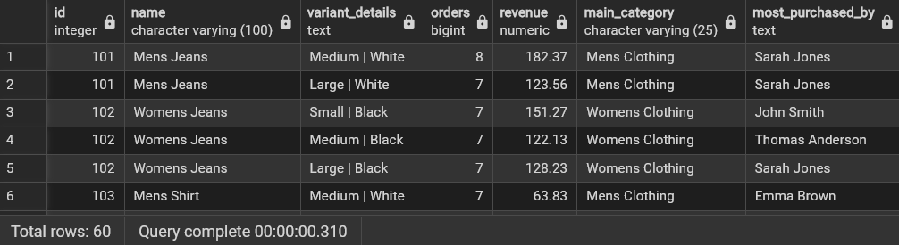

I’ve included the screenshot of the first 3 documents from the results, which also includes the total number of documents in the results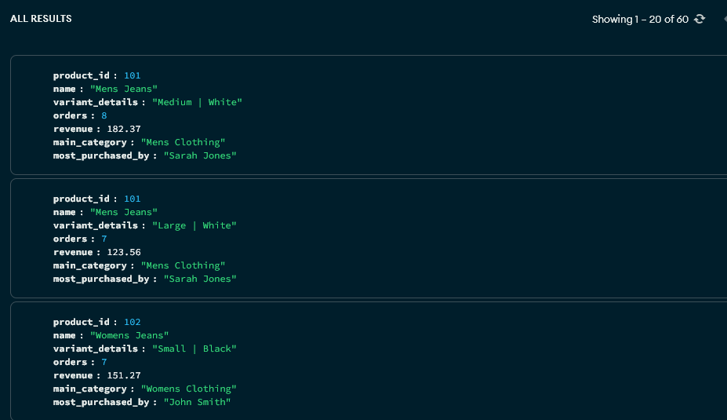

Query b: A query which uses one (or more) of the UNION, DIFFERENCE or INTERSECT operators.

This query emulates an inventory export that can be used by the procurement team to order new stock or given to a dropshipper that wishes to resell the products on their website. It has all the details of each variant.

In this query, the variants are unnested and cross-joined to list all the variants of a product table. This is done for all the products tables, and they are joined with a UNION ALL between each table.

In NoSQL, it is done in just 2 stages, as all the products are stored in one table. If a type-specific field does not exist, it is not listed.

Exporting the results of both gives the exact same CSV file with a minor difference, i.e. the missing fields are empty in the NoSQL export but have the value NULL in the SQL report.
SQL code
SELECT
v.sku AS sku,
p.name AS product,
p.base_price + v.price_adjustment AS price,
CONCAT(v.size, ' | ', v.color) AS variant_details,
v.stock_quantity AS stock,
p.fabric_type AS material,
NULL AS warranty,
NULL AS voltage,
NULL AS made_for
FROM clothing_products p
CROSS JOIN unnest(p.variants) v

UNION ALL

SELECT
v.sku AS sku,
p.name AS product,
p.base_price + v.price_adjustment AS price,
CONCAT(v.size, ' | ', v.color) AS variant_details,
v.stock_quantity AS stock,
NULL AS fabric,
p.warranty_period AS warranty,
p.voltage_requirements AS voltage,
NULL AS made_for
FROM electronics_products p
CROSS JOIN unnest(p.variants) v

UNION ALL

SELECT
v.sku AS sku,
p.name AS product,
p.base_price + v.price_adjustment AS price,
CONCAT(v.size, ' | ', v.color) AS variant_details,
v.stock_quantity AS stock,
p.material AS material,
NULL AS warranty,
NULL AS voltage,
p.pet_type AS made_for
FROM pet_products p
CROSS JOIN unnest(p.variants) v;
MongoDB code
db.products.aggregate([
{ $unwind: {
path: "$variants",
preserveNullAndEmptyArrays: true
}},
{ $project: {
_id: 0,
sku: "$variants.sku",
product: "$name",
price: { $round: [ { $add: [ "$base_price", "$variants.price_adjustment" ]}, 2 ] },
variant_details: { $cond: { if: "$variants.size", then: { $cond: { if: "$variants.color", then: { $concat: [ "$variants.size", " | ", "$variants.color" ]}, else: { $concat: [ "$variants.size", " | " ]}}}, else: { $concat: [" | ", "$variants.color"]}}},
stock: "$variants.stock_quantity",
material: { $cond: { if: "$fabric_type", then: "$fabric_type", else: "$material" }},
warranty: "$warranty_period",
voltage: "$voltage_requirements",
made_for: "$pet_type"
}
}
]);
Screenshots
I’ve only included a screenshot of a few rows, but also a screenshot of an exported CSV file (with folded rows to display every type of product) as this query would mostly be used to get an inventory list from the application:
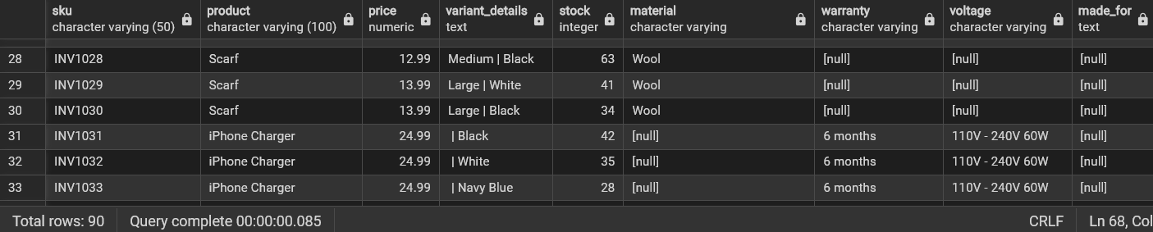
CSV export:
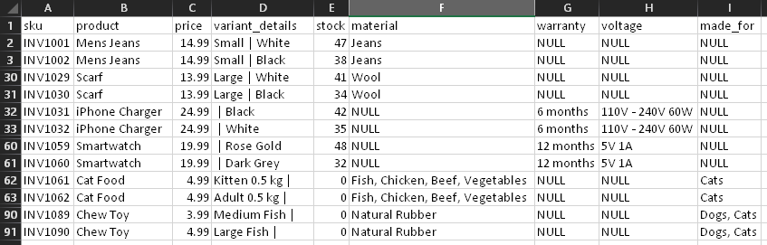

I’ve included a few documents from the results with the total count of the results. However, a better comparison is the CSV export, so I have also included that.
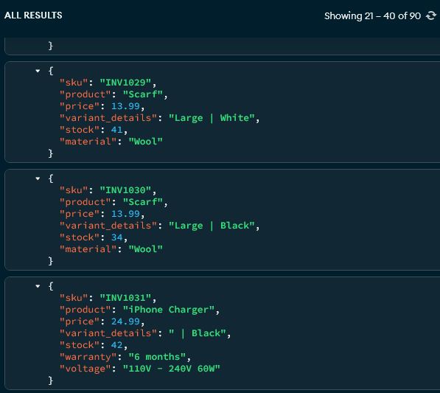
CSV export:
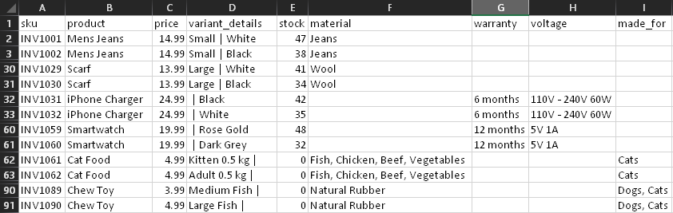

Query c: A query which requires use of either an array or table inheritance

This query updates the price_adjustment field of a variant inside the variants array in the products table and the last_modified is set to the current timestamp. The specific price increment of a variant might need to be adjusted depending on the varying cost of a product if purchased from a different supplier or the increase in price over time from the manufacturer.

In SQL, this is done with a stored procedure to update pricing and a trigger to update last_modified, and then a select query is run to show the updated price on the variant. The Select query can be run before the procedure to show the old price of the variant.

In NoSQL, this is done with the updateOne method, and then an aggregation pipeline is run to display the updated price. Similar to the SQL query, the aggregation pipeline can be run before the update method to display the old price of the variant.
Both queries update the price for the product with id 305 and its first variant with id 1; the new price is set to 3.00. Of course, it can be changed manually, but will be done by passing variables in the queries from the backend in a production environment.
SQL code
CALL update_variant_price(305, 1, 3.00);

SELECT p.name, CONCAT(p.variants[1].size, ' | ', p.variants[1].color) AS variant_details, p.variants[1].price_adjustment AS variant_price, p.last_modified
FROM products p
WHERE p.product_id = 305;
MongoDB code
db.products.updateOne({
product_id: 305,
"variants.variant_id": 1
},
{ $set:{
"variants.$.price_adjustment": 3.00,
last_modified: new Date()
}
});

db.products.aggregate([
{ $unwind: {
path: "$variants",
preserveNullAndEmptyArrays: true
}},
{ $match: {
product_id: 305,
"variants.variant_id": 1
}},
{ $project: {
_id: 0,
name: "$name",
variant_details: { $cond: { if: "$variants.size", then: { $cond: { if: "$variants.color", then: { $concat: [ "$variants.size", " | ", "$variants.color" ]}, else: { $concat: [ "$variants.size", " | " ]}}}, else: { $concat: [" | ", "$variants.color"]}}},
variant_price: "$variants.price_adjustment",
last_modified: "$last_modified"
}
}
]);
Screenshots
Old pricing and timestamp by running the SELECT query below the price update query:
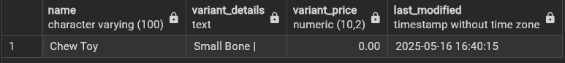
New pricing and last_modified timestamp after running the price update query and the select query to display the updated fields:
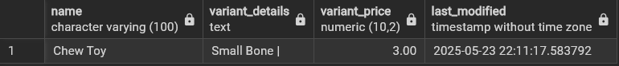

Old pricing by just running the aggregate pipeline below the update query:
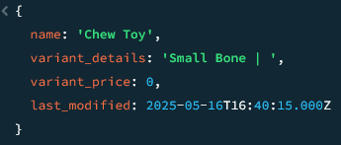
New pricing and last_modified timestamp after running the entire code block:
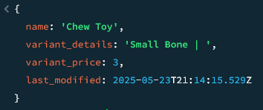

Query d: A query using temporal features (e.g., timestamps, intervals, etc.)

This query shows all the orders in the last 60 days with all the related details fetched from referenced entities. This would be used on an orders page that displays all orders. There would be a time interval constraint by default to not load too many orders at once and slow down the page load time. The time interval is hard-coded as 60 days (which can be manually changed in the queries), but it would be passed as a variable in the backend implementation.

SQL code
SELECT
o.order_id,
CONCAT(u.forenames, ' ' ,u.last_name) AS customer,
p.name AS product,

CONCAT(p.variants[(o.item).variant_id].size, ' | ', p.variants[(o.item).variant_id].color) AS variant_details,

(o.item).quantity,
(o.item).unit_price,
(o.item).discount_amount AS discount,
o.total_amount AS order_total,
(o.shipping_address).recipient_name AS recipient,
(o.shipping_address).street AS street_address,
(o.shipping_address).city AS city,
(o.shipping_address).zip_code AS postal_code,
(o.shipping_address).country AS country
FROM orders o
JOIN users u ON o.user_id = u.user_id
JOIN products p ON (o.item).product_id = p.product_id
WHERE o.created_at > CURRENT_TIMESTAMP - interval '60 days'
ORDER BY o.order_id;
MongoDB code
db.orders.aggregate([
{ $match: {
$expr: { $gt: [ "$created_at", { $dateSubtract: { startDate: "$$NOW", unit: "day", amount: 60 }}]}
}},
{ $lookup: {
from: "products",
localField: "item.product_id",
foreignField: "product_id",
let: { vid: { $subtract: ["$item.variant_id", 1]}},
pipeline: [
{ $project: {
_id: 0,
name: "$name",
variant_size: {
$arrayElemAt: [ "$variants.size", "$$vid"]},
variant_color: { $arrayElemAt: [ "$variants.color", "$$vid" ]}
}}],
as: "product"
}},
{ $unwind: {
path: "$product",
preserveNullAndEmptyArrays: true
}},
{ $project: {
_id: 0,
order_id: "$order_id",
customer: "$user",
product: "$product.name",
variant_details: { $cond: { if: "$variants.size", then: { $cond: { if: "$variants.color", then: { $concat: [ "$variants.size", " | ", "$variants.color" ]}, else: { $concat: [ "$variants.size", " | " ]}}}, else: { $concat: [" | ", "$variants.color"]}}},
quantity: "$item.quantity",
unit_price: "$item.unit_price",
discount: "$item.discount_amount",
order_total: "$total_amount",
recipient: "$shipping_address.recipient_name",
street_address: "$shipping_address.street",
city: "$shipping_address.city",
postal_code: "$shipping_address.zip_code",
country: "$shipping_address.country"
}
}
]);
Screenshots
At the time of running this query, there were 53 orders in the last 60 days. The screenshot has only a few records displayed from the result but the total count can be seen on the bottom.
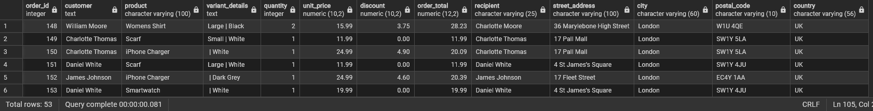

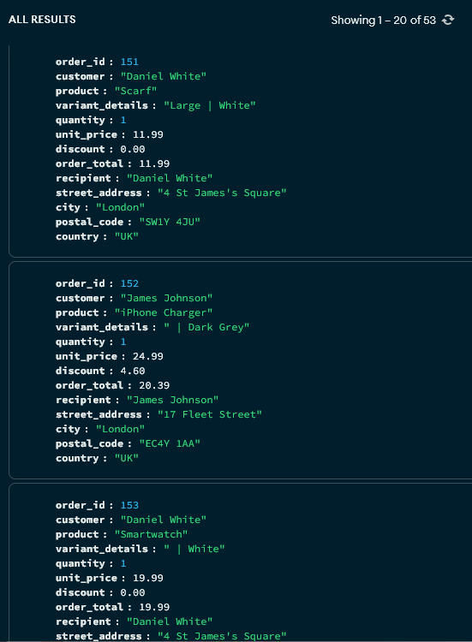
The MongoDB query also returns the same results

Query e: A query using OLAP (e.g., ROLLUP, CUBE, PARTITION) features

This query shows the total number of orders and the accumulated revenue from a user, broken down into years and months. This would usually be shown on the user profile in the admin dashboard to see how much a user has spent. It is crucial to know who the best buyer is in order to retain their business.

SQL code
SELECT
u.user_id AS id,
CONCAT(u.forenames, ' ' ,u.last_name) AS name,
EXTRACT(YEAR FROM o.created_at) AS year,
EXTRACT(MONTH FROM o.created_at) AS month,
count(o.*) AS orders,
sum(o.total_amount) AS revenue
FROM
users u
JOIN orders o ON u.user_id = o.user_id
WHERE u.user_id = 2
GROUP BY id, ROLLUP(year, month)
ORDER BY year DESC, month DESC;
MongoDB code
db.users.aggregate([
{ $match: {
user_id: 2
}},
{ $lookup: {
from: "orders",
localField: "user_id",
foreignField: "user_id",
pipeline: [ {
$project: {
_id: 0,
revenue: "$total_amount",
placed: "$created_at"
}}
],
as: "rorders"}},
{ $unwind: {
path: "$rorders",
preserveNullAndEmptyArrays: true
}},
{ $group: {
_id: {
id: "$user_id",
name: { $concat: [ "$forenames", " ", "$last_name" ]},
year: { $year: "$rorders.placed" },
month: { $month: "$rorders.placed" }
},
orders: { $sum: 1 },
revenue: { $sum: "$rorders.revenue" }
}},
{ $sort: {
"_id.year": -1,
"_id.month": -1
}},
{ $facet: {
total_stats: [
{ $group: {
_id: {
id: "$_id.id",
name: "$_id.name"
},
total_orders: { $sum: "$orders" },
total_revenue: { $sum: "$revenue" }
}},
{ $project: {
_id: "$_id.id",
name: "$_id.name",
total_orders: "$total_orders",
total_revenue: "$total_revenue"
}}
],
detailed_stats: [
{ $group: {
_id: { year: "$_id.year" },
yearly_orders: { $sum: "$orders" },
yearly_revenue: { $sum: "$revenue" },
monthly_data: {
$push: {
month: "$_id.month",
orders: "$orders",
revenue: "$revenue"
}
}
}},
{ $sort: {
"_id.year": -1
}}
]
}}
]);
Screenshots
Here is the screenshot of the total revenue by the user in the PostgreSQL. It is broken down by year and then by month.
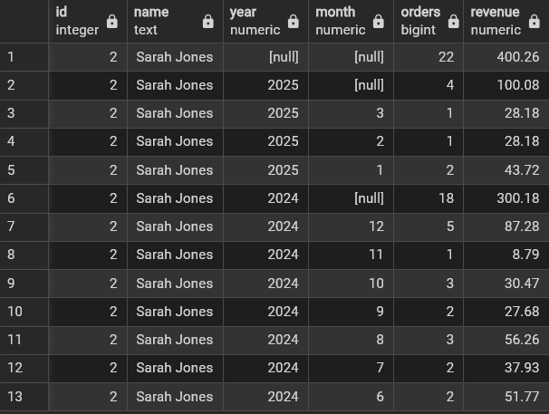

Here are the screenshots of the MongoDB result. It is also broken down into years and then months within the years. There are multiple screenshots as the result was a bit too long in Compass. It is not exactly in the same format, but it is providing the exact same data as the SQL query.

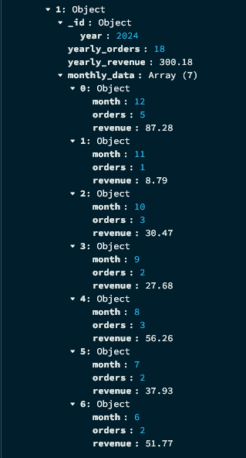
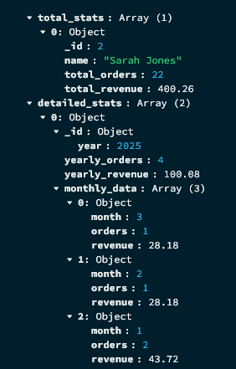

References:

Strausz, P. (2023) [Part3] PostgreSQL Relationships: Creating and Managing Database Relationships. Available at: https://medium.com/@patrikstrausz17/part3-postgresql-relationships-creating-and-managing-database-relationships-5e1eaea769d8#:~:text=To%20implement%20a%20many%2Dto%2Dmany%20relationship%20in%20PostgreSQL (Accessed: 13 May, 2025)

MongoDB Docs (no date) Reduce $lookup Operations. Available at: https://www.mongodb.com/docs/atlas/schema-suggestions/reduce-lookup-operations/#:~:text=slow%20and%20resource%2Dintensive (Accessed: 19 May 2025)

Gupta, A. (2024) Advanced Techniques with MongoDB: Mastering Lookup and Unwind. Available at: https://medium.com/@akshatgupta1903/advanced-techniques-with-mongodb-mastering-lookup-and-unwind-acfc8a8ad5b9#:~:text=Indexing%20is%20a%20critical%20factor (Accessed: 19 May 2025)

